**SOLUTION-ORIENTED ICT DATA ANALYSIS REPORT: EVALUATING 30 INDIAN CITIES WITH A FOCUS ON BHOPAL**

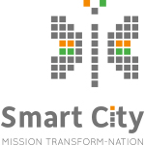

**Prepared by:**

**Sandeep Devra**

**Date: - 25-8-2024**

**Table of Contents**

1. **Executive Summary**
2. **Introduction**
   * Background of Smart City Mission
   * Importance of ICT in Smart Cities
   * Objectives of the Analysis
3. **Data Collection and Methodology**
   * Sources of Data
   * Selection of Cities and Parameters
   * Analytical Approach
4. **Overall ICT Performance of 30 Indian Cities (2019-2024)**
   * Top 10 Cities by Average of All Features
   * Analysis of Wi-Fi Availability in Public Areas
   * ICT Feature Presence in Indian Cities
5. **Case Study: ICT Analysis of Bhopal**
   * Overview of ICT Performance in Bhopal
   * Detailed Analysis of Selected ICT Features
6. **Comparative Analysis: Bhopal vs. Top Cities**
7. **Key Findings**
   * Performance Gaps in ICT Infrastructure
   * Trends Observed in Bhopal
   * Comparative Insights
8. **International Best Practices**
   * Overview of ICT Solutions in Developed Countries
   * Case Studies:
     + **USA**: Smart Infrastructure Initiatives
     + **Canada**: Digital Government Services
     + **UK**: Open Data and Public Participation
     + **Japan**: Advanced Transportation and Traffic Management
9. **Recommended Solutions for Bhopal**
   * Strengthening ICT Infrastructure
   * Enhancing Public Wi-Fi Availability
   * Implementing Smart Water and Electricity Meters
   * Improving Dynamic Public Transport Information
   * Expanding Open Data Initiatives
   * Deploying Intersection Control and Traffic Monitoring Systems
10. **Conclusion**
    * Summary of Key Points
    * The Way Forward for Bhopal and Other Indian Cities
11. **References**

**1. Executive Summary**

The Smart City Mission in India is a transformative initiative aimed at enhancing the quality of urban life through the deployment of advanced ICT (Information and Communication Technology) systems. This report provides an in-depth analysis of ICT data across 30 Indian cities, with a particular focus on Bhopal. The analysis covers 17 critical ICT parameters from 2019 to 2024. While major cities like Mumbai, Delhi, and Bengaluru show relatively better ICT performance, a significant number of cities, including Bhopal, lag behind in key areas. This report outlines the current socio-economic challenges related to ICT infrastructure in these cities and proposes solutions inspired by international best practices.

**2. Introduction**

**Background of Smart City Mission**

The Smart City Mission, launched by the Government of India, aims to promote sustainable and inclusive cities that provide core infrastructure, a clean and sustainable environment, and a decent quality of life for their citizens. ICT plays a pivotal role in achieving these objectives, acting as the backbone of smart city development.

**Importance of ICT in Smart Cities**

ICT enables cities to improve public services, enhance resource management, and engage citizens more effectively. From smart meters to dynamic public transport information, these technologies are essential for modern urban management.

**Objectives of the Analysis**

The objective of this analysis is to assess the current status of ICT implementation in 30 Indian cities, identify gaps, and propose actionable solutions for Bhopal, based on global best practices.

**3. Data Collection and Methodology**

**Sources of Data**

Data for this analysis was exclusively sourced from the data.gov.in portal, the official government website providing access to a wide range of public datasets. This platform serves as a comprehensive repository for government data, ensuring the analysis is based on reliable and authoritative information.

**Selection of Cities and Parameters**

Thirty cities were selected for this study, representing a diverse cross-section of urban India. Seventeen ICT-related parameters were chosen to provide a comprehensive view of each city's progress in smart city initiatives.

**Analytical Approach**

The analysis was conducted using a combination of descriptive statistics and trend analysis, with a focus on year-over-year changes from 2019 to 2024. Bhopal was analyzed in detail, particularly in areas where its performance was below 45%.

**4. Overall ICT Performance of 30 Indian Cities (2019-2024)**

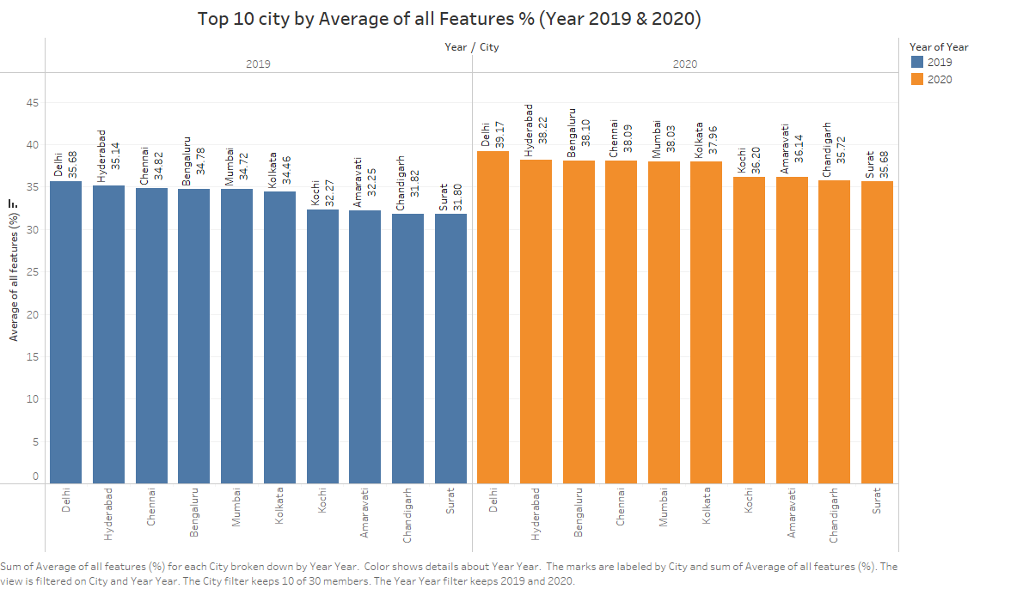

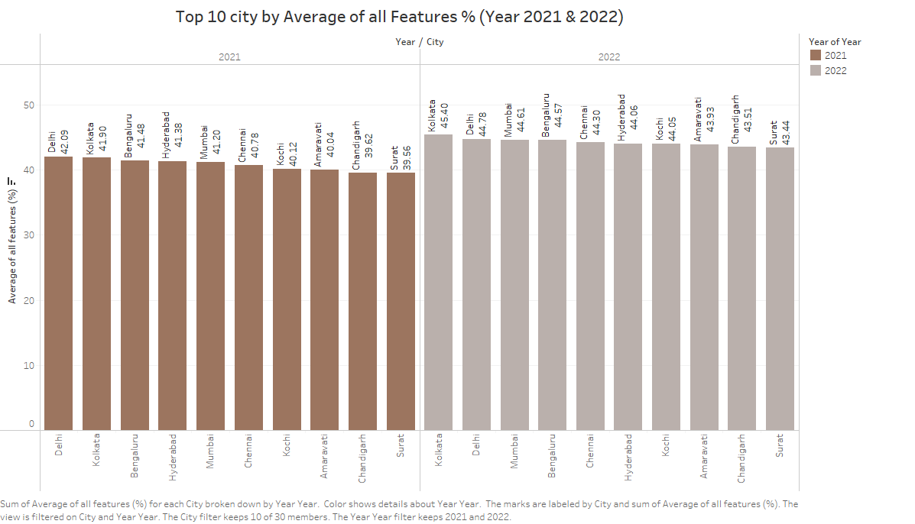

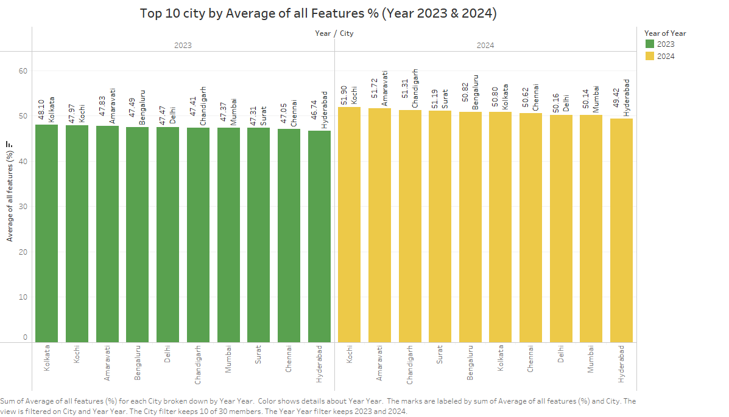

The analysis reveals that cities like Mumbai, Delhi, Bengaluru, Chennai, and Kolkata are leading in ICT implementation. However, even these cities have not yet reached the optimal levels required to fully achieve smart city status.

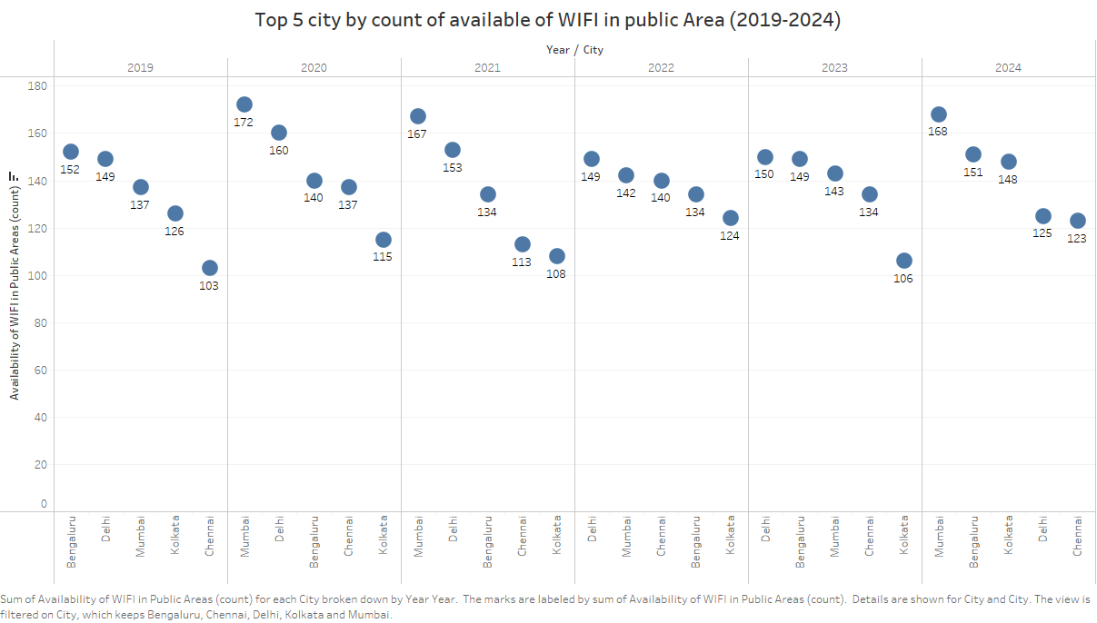

Wi-Fi availability in public areas has seen some growth, but coverage remains inconsistent across the majority of cities.

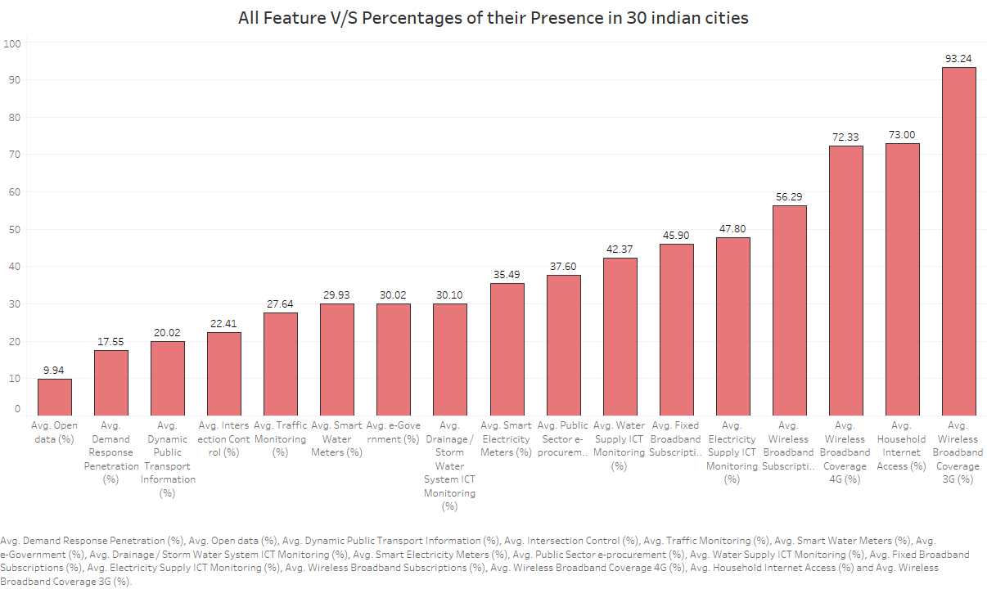

The majority of cities show underperformance across multiple ICT parameters, highlighting the need for targeted interventions.

**5. Case Study: ICT Analysis of Bhopal**

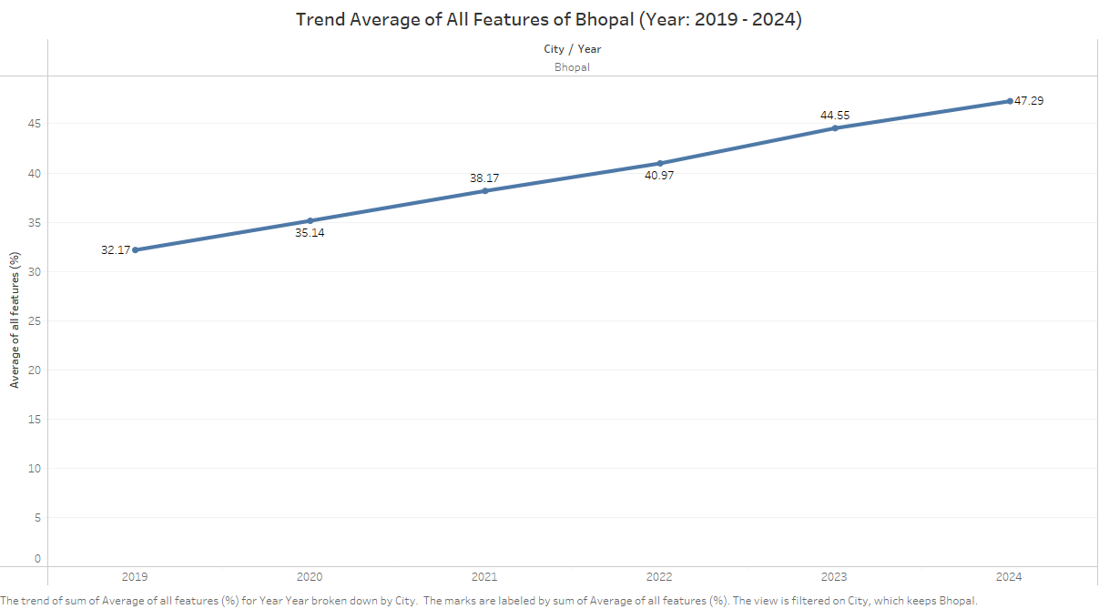

Bhopal's performance in ICT features is below 45% for 12 out of the 17 parameters analyzed. This section explores these parameters in detail.

**Overview of ICT Performance in Bhopal**

Bhopal's ICT infrastructure is underdeveloped in several key areas, such as smart water meters, dynamic public transport information, and open data initiatives. The city has shown some progress in areas like traffic monitoring and intersection control, but these remain limited in scope.

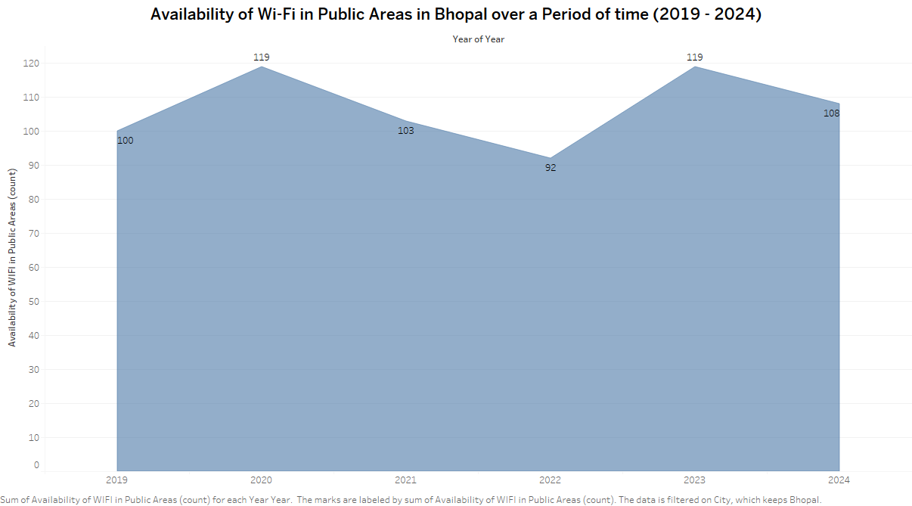

Wi-Fi coverage in Bhopal's public areas has remained stagnant over the years, with minimal growth observed.

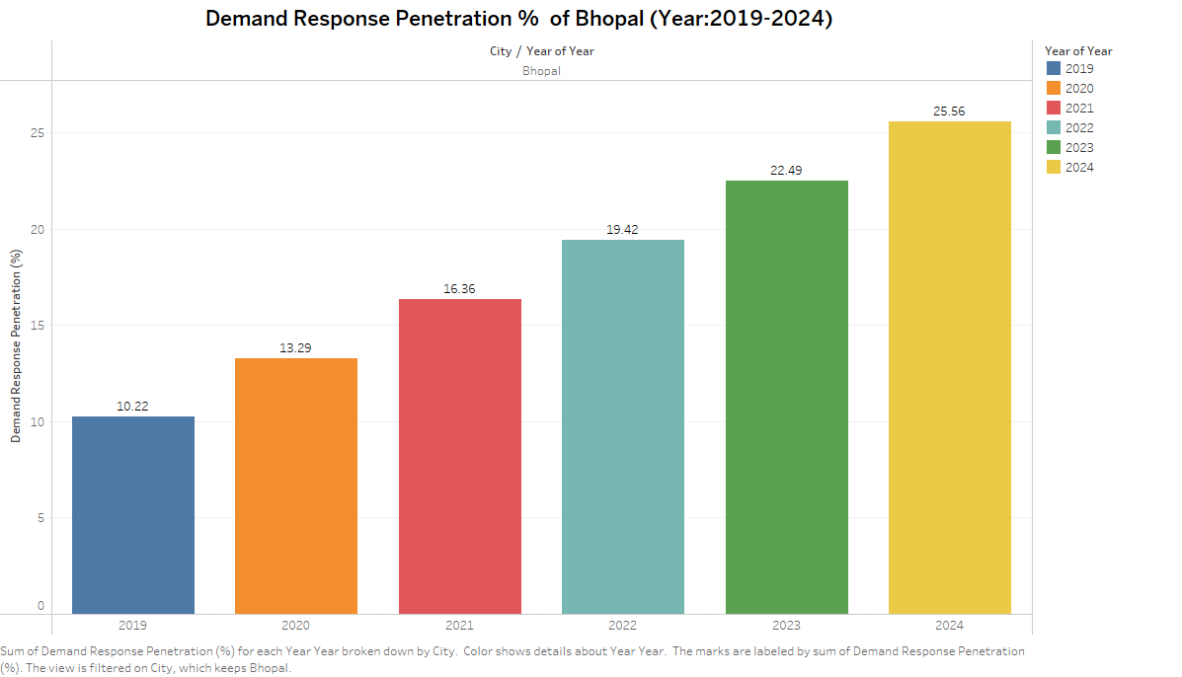Demand response systems, crucial for managing electricity consumption, show limited penetration in Bhopal.

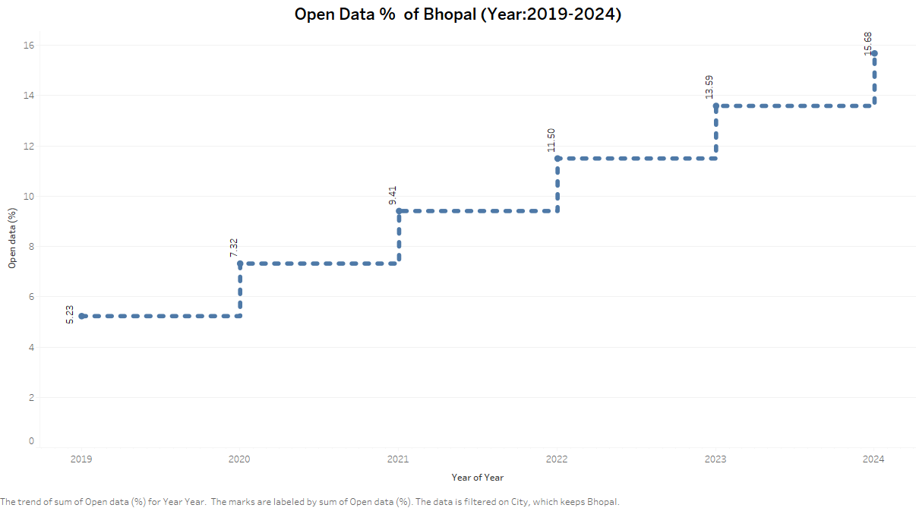

Open data initiatives, which are essential for transparency and citizen engagement, are still in nascent stages in Bhopal.

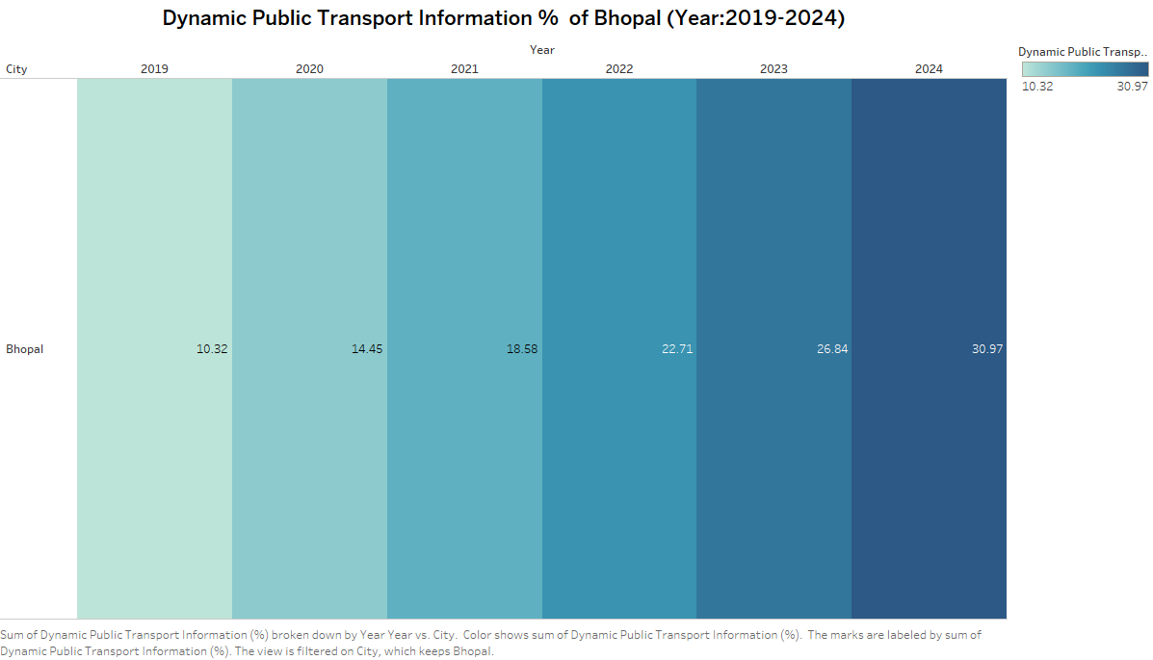

Dynamic public transport information systems are poorly developed, impacting the efficiency and reliability of public transport.

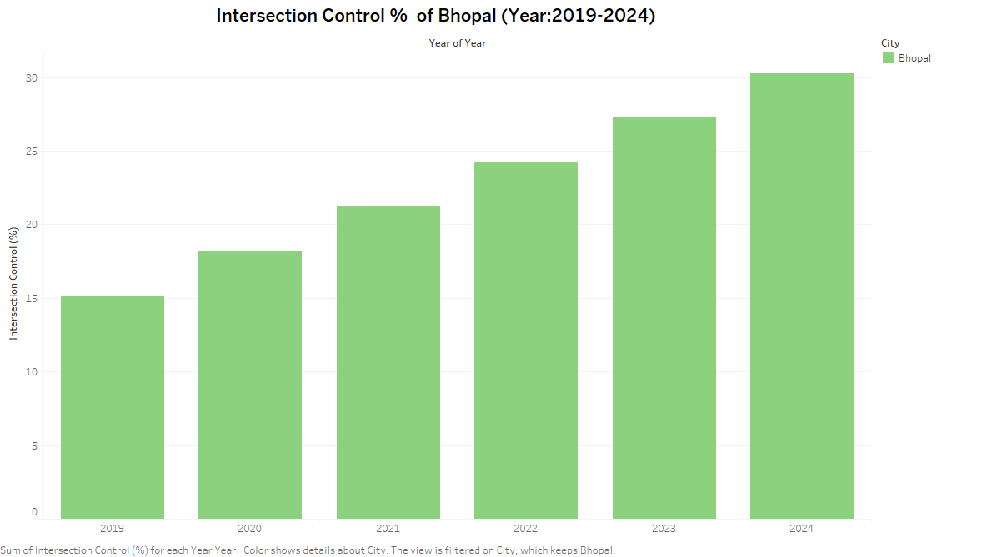

Intersection control systems, while present, cover only a fraction of the city's traffic intersections.

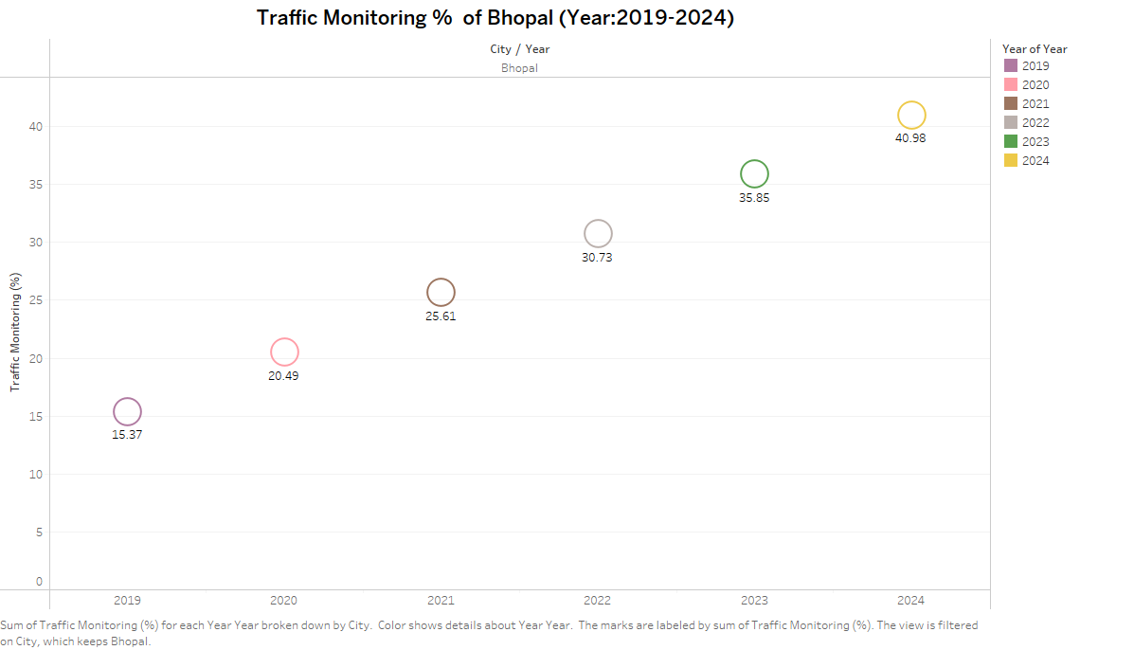

Traffic monitoring has improved slightly, but the overall coverage is insufficient to address the city's growing traffic challenges.

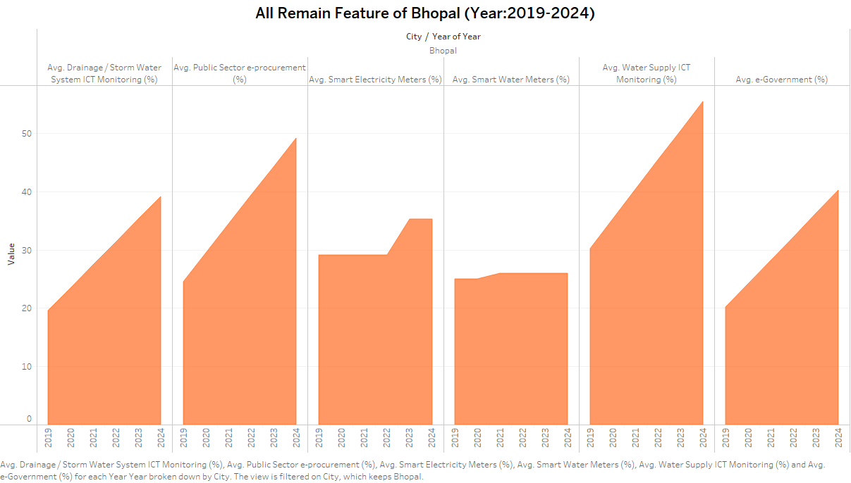

This combined analysis highlights Bhopal's shortcomings in smart water and electricity meters, water supply monitoring, drainage ICT monitoring, e-Government services, and public sector e-procurement.

**6. Comparative Analysis: Bhopal vs. Top Cities**

In comparison to cities like Mumbai, Delhi, and Bengaluru, Bhopal's ICT infrastructure is significantly underdeveloped. The gap is particularly wide in areas such as public Wi-Fi availability, smart utility meters, and open data initiatives. This disparity underscores the need for focused interventions in Bhopal to bring it on par with the leading cities.

**7. Key Findings**

**Performance Gaps in ICT Infrastructure**

* Bhopal, along with several other cities, exhibits substantial gaps in ICT infrastructure, particularly in the deployment of smart meters, public Wi-Fi, and open data initiatives.
* The trend analysis shows that while there has been some progress over the years, the overall pace of ICT development is slow.

**Trends Observed in Bhopal**

* Bhopal's ICT development is inconsistent, with some areas showing slight improvement while others remain stagnant.
* The city's overall ICT infrastructure score is below the national average, highlighting the need for accelerated efforts.

**Comparative Insights**

* Cities like Mumbai and Delhi, although better equipped, still face challenges in achieving the desired levels of ICT implementation.
* The comparison indicates that even top-performing cities in India have a long way to go before they can be considered truly "smart."

**8. International Best Practices**

**Overview of ICT Solutions in Developed Countries**

Developed countries have successfully implemented various ICT solutions that have significantly improved urban management and citizen services. These practices provide valuable insights that can be adapted to the Indian context.

**Case Studies**

**USA: Smart Infrastructure Initiatives**

The United States has made significant strides in smart infrastructure, particularly in the areas of traffic management, public transport information systems, and utility management. Cities like New York and San Francisco have implemented advanced traffic monitoring and intersection control systems, resulting in reduced congestion and improved traffic flow. The adoption of smart meters for water and electricity management has also led to more efficient resource utilization.

**Canada: Digital Government Services**

Canada is a leader in digital government services, with a strong emphasis on citizen engagement and open data initiatives. The country's e-Government platforms provide a wide range of services online, making it easier for citizens to interact with government agencies. The focus on open data has also improved transparency and accountability, fostering greater public trust.

**UK: Open Data and Public Participation**

The UK has pioneered open data initiatives, making vast amounts of public data available for analysis and innovation. This has led to the development of numerous applications and services that improve urban living. The UK's emphasis on public participation in smart city initiatives has also ensured that these projects are aligned with the needs and preferences of citizens.

**Japan: Advanced Transportation and Traffic Management**

Japan is known for its advanced transportation systems, which include real-time public transport information, smart ticketing, and integrated traffic management. These systems have not only improved the efficiency of public transport but have also contributed to reducing traffic congestion and emissions in major cities like Tokyo and Osaka.

**9. Recommended Solutions for Bhopal**

**Strengthening ICT Infrastructure**

Bhopal should prioritize the development of its ICT infrastructure, focusing on areas such as smart meters, public Wi-Fi, and dynamic public transport information systems. Collaborating with private sector partners and leveraging central government schemes can help accelerate this development.

**Enhancing Public Wi-Fi Availability**

To improve connectivity, Bhopal should expand its public Wi-Fi coverage, particularly in high-traffic areas such as markets, public parks, and transportation hubs. Learning from the examples of cities like New York and London, Bhopal can deploy cost-effective solutions like mesh networks to enhance coverage.

**Implementing Smart Water and Electricity Meters**

Smart meters can significantly improve resource management and reduce waste. Bhopal should implement a phased rollout of smart water and electricity meters across the city, starting with commercial areas and high-consumption residential zones.

**Improving Dynamic Public Transport Information**

Bhopal should invest in dynamic public transport information systems that provide real-time updates to commuters. Integrating these systems with mobile applications and public displays can improve the efficiency and reliability of the city's public transport network.

**Expanding Open Data Initiatives**

Bhopal should launch an open data portal to make government data accessible to the public. This initiative will promote transparency and enable citizens and businesses to develop innovative solutions based on publicly available data.

**Deploying Intersection Control and Traffic Monitoring Systems**

To address traffic congestion, Bhopal should deploy advanced intersection control systems and expand its traffic monitoring capabilities. Implementing adaptive traffic signal control, as seen in cities like Singapore and London, can help optimize traffic flow and reduce delays.

**10. Conclusion**

This analysis has highlighted the significant challenges facing Bhopal and other Indian cities in terms of ICT infrastructure development. While some progress has been made, much more needs to be done to realize the vision of smart cities in India. By adopting best practices from developed countries and focusing on targeted interventions, Bhopal can significantly improve its ICT performance and set an example for other cities to follow.

**11. References**

Data for this analysis was sourced from the data.gov.in portal, which provides access to a broad range of public datasets. Additionally, some analytical approaches and methodologies were inspired by resources and community contributions on Kaggle.